

Subject Code: EEET1368

Student Name: Aditya Prawira

Student Number: 3859061

Assignment Title: Mid-semester Assignment

Due date: April 16th, 2021

Table of Contents

Part 1 2

Part 2 6

Part 3 12

Part 4 16

# Part 1

PI controller is desired to be implemented into a closed-loop system to regulate fluid level inside the water tank. The closed-loop system will take flow rate as an input which is represented a unit step-point signal $r\left(t\right)=R_{0}=1$. On the other hand, the closed-loop system will produce output signal for the fluid level inside the tank represented as $y(t)$. The transfer function that represent the level control of the water tank system is denoted as

$$G\left(s\right)= \frac{0.01}{10s+1}$$

The desired closed-loop polynomial will be in form of $s^{2}+2ξω_{n}s + ω_{n}^{2}$, where the damping coefficient and natural frequency are set to be $ξ=0.707$, and $ω_{n}=1 rad/s$.

Now, let’s convert the transfer function of the system to have form of

$$G\left(s\right)= \frac{b}{s+a}$$

Therefore,

$$G\left(s\right)=\frac{b}{s+a}=\frac{0.001}{s+0.1}, where a=0.1, and b=0.001$$

Now, the expected PI controller would be in form of

$$C\left(s\right)= K_{c}\left(1+ \frac{1}{τ_{I}s}\right)$$

Where the general form of the controller would be represented as

$$C\left(s\right)= \frac{c_{1}s+ c_{0}}{s}$$

Then,

$$K_{c}=c_{1}$$

$$\frac{K_{c}}{τ_{I}}=c_{0}⟹ τ_{I}= \frac{K_{c}}{c_{0}}$$

Now, to calculate the actual closed-loop system

$$T_{cl}\left(s\right)= \frac{G(s)C(s)}{1+G(s)C(s)}$$

Therefore, let’s calculate $G(s)C(s)$ to simplify the rest of the calculation.

$$G\left(s\right)C\left(s\right)=\left(\frac{b}{s+a}\right)\left(\frac{c_{1}s+ c_{0}}{s}\right)$$

$$G\left(s\right)C\left(s\right)=\frac{b(c_{1}s+ c_{0})}{s(s+a)}$$

Therefore,

$$T_{cl}\left(s\right)= \left(\frac{b(c_{1}s+ c_{0})}{s(s+a)}\right)\left(\frac{s(s+a)}{s\left(s+a\right)+ b(c_{1}s+ c_{0}) }\right)$$

$${∴ T}_{cl}\left(s\right)= \left(\frac{b(c_{1}s+ c_{0})}{s\left(s+a\right)+ b(c_{1}s+ c_{0})}\right)$$

From this point, equate the denominator of $T_{cl}(s)$ with the desired polynomial of the closed-loop system.

$$∴ s\left(s+a\right)+ b\left(c_{1}s+ c_{0}\right)= s^{2}+2ξω_{n}s + ω_{n}^{2}$$

$$⟹ s^{2}+\left(a+bc_{`1}\right)s + bc_{0}= s^{2}+2ξω_{n}s + ω_{n}^{2}$$

By coefficient parameters are able to be found as

$$s:a+bc_{1}=2ξω_{n} ⟹ c_{1}= \frac{2ξω_{n}-a}{b}$$

$$constant:bc_{0}=ω_{n}^{2} ⟹ c_{0}= \frac{ω_{n}^{2}}{b}$$

By the fact that the value of $a=0.1$, $b=0.001$, $ξ=0.707$, and $ω_{n}=1 rad/s$, Let’s implement FirstOrderPI.m class top find the value of $K_{c}$, and $τ_{I}$.

%% Created by: Aditya Prawira

% RMIT ID: S3859061

classdef FirstOrderPI

properties

Kc; tauI;

Cs; P; I;

end

methods

function obj = FirstOrderPI(wn, zeta, a, b)

c1 = (2*zeta*wn - a)/b;

c0 = wn^2 / b;

obj.Kc = c1;

obj.tauI = c1/c0;

obj.Cs = tf([c1 c0], [1 0]);

obj.P = obj.Kc;

obj.I = obj.Kc/obj.tauI;

end

end

end

**Figure 1.** FirstOrderPI.m custom MATLAB class

**Figure 2.** params1.m MATLAB program that generate parameters for SIMULINK simulation.

%% Created by: Aditya Prawira

% RMIT ID: S3859061

clear

clc

close all

a = 0.1; b = 0.001;

zeta = 0.707; wn = 1;

time = 20;

Gs = tf(b, [1 a]);

pi = FirstOrderPI(wn, zeta, a, b);

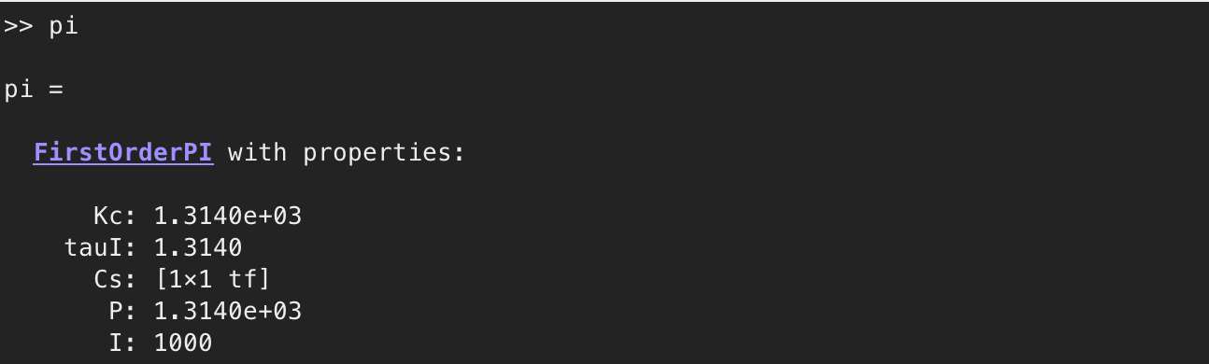

**Figure 3.** Parameters generated by utilising FirstOrderPI.m MATLAB class.

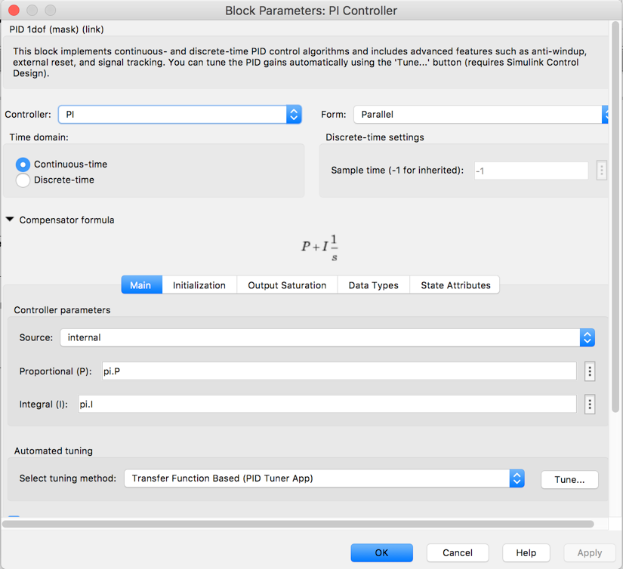

**Figure 4.** PI controller configuration.

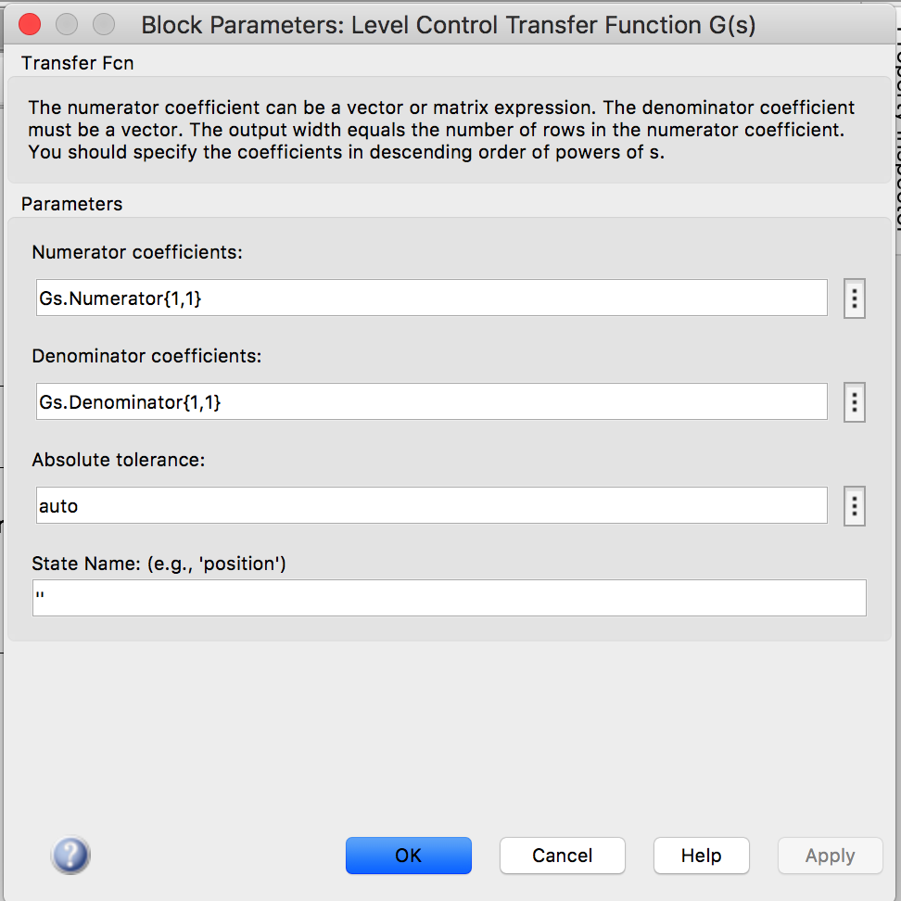

**Figure 5.** Level control transfer function configuration

The simulation will utilize simulation time of 20 seconds, and sampling interval of $∆t=0.1s$.

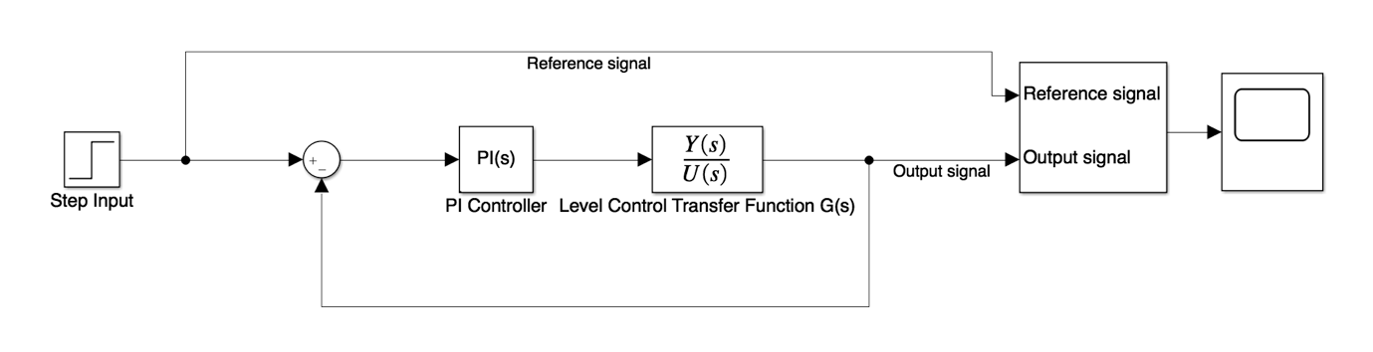

**Figure 6.** Simulink diagram of the simulation (sim1.slx)

By running params1.m file and run sim1.slx the output of the simulation will produced as shown below.



**Figure 7.** Closed-loop system plot of output and reference signal

As what has been shown in the plot there will be an overshoot around ~ 1.18, and will eventually reaches the value of the step response amplitude since it is proven by final value theorem that

$$\lim_{t→∞}{y\left(t\right)=\lim_{s→0}{sY\left(s\right)=R_{0}}}$$

The system produce an acceptable stability and a decent response speed.

# Part 2

A resource company has a process unit which is represented by the first order plus delay transfer function of

$$G\left(s\right)=\frac{0.5e^{-6s}}{(s+1)}$$

In this task, PID controller design is required to be implemented on the system. The PID controller must be design in order to produce a stable closed-loop system. It is known that all poles of the desired closed-loop my start and are located at -1 ($λ=1$). It is expected that PID design must enhance the closed-loop system to produce the stable system with the fastest response speed, and has not oscillation. The result can be achieved by reducing the magnitude of poles by half. Furthermore, pole cancellation technique is allowed to be utilized to design the PID controller. Now, by utilising Pade’s approximation

$$G\left(s\right)= \frac{K_{p}e^{-ds}}{(τ_{p}s+1)}≈\frac{K_{p}(-ds+2)}{(τ_{p}s+1)(ds+2)}$$

$$G\left(s\right)= \frac{0.5e^{-6s}}{(s+1)}≈\frac{0.5\left(-6s+2\right)}{\left(s+1\right)\left(6s+2\right)}=\frac{-\frac{1}{2}s+ \frac{1}{6}}{(s+1)(s+ \frac{1}{3})}$$

Model based PID,

$$G\left(s\right)=\frac{-\frac{1}{2}s+ \frac{1}{6}}{(s+1)(s+ \frac{1}{3})}= \frac{b_{1}s+ b_{0}}{(s+ α_{1})(s+ α_{2})}$$

$$where τ_{p}=1, d=6 (time delay)$$

There are scenarios that must be consider for this model. Those scenarios denoted that

$$if\left(\frac{1}{τ_{p}}> \frac{2}{d}\right) ⇒ \left(α_{1}= \frac{2}{d}\right)⋀\left(α_{2}= \frac{1}{τ_{p}}\right)$$

$$if\left(\frac{1}{τ_{p}}< \frac{2}{d}\right) ⇒ \left(α_{1}= \frac{1}{τ_{p}}\right)⋀\left(α_{2}= \frac{2}{d}\right)$$

Therefore, in this particular case the value of $α_{1}$, and $α_{2}$ can be set as shown below $$α_{1}= \frac{1}{3}, {\& α}_{2}=1$$

Assuming the general form of PID controller transfer function would be in form of

$$C\left(s\right)= \frac{c_{2}s^{2}+c_{1}s+ c_{0}}{s(s+ I_{0})}$$

Now, consider the actual closed-loop transfer function

$$T_{cl}\left(s\right)= \frac{G(s)C(s)}{1+G(s)C(s)}$$

First, let’s calculate $G(s)C(s)$ to simplify the rest of the calculation.

$$G\left(s\right)C\left(s\right)=\left(\frac{b_{1}s+ b_{0}}{(s+ α_{1})(s+ α_{2})}\right)\left(\frac{c_{2}s^{2}+c_{1}s+ c_{0}}{s(s+ I_{0})}\right)=\left(\frac{b_{1}s+ b_{0}}{(s+ α_{1})(s+ α_{2})}\right)\left(\frac{c_{2}(s+γ_{1} )(s+ α_{2})}{s(s+ I_{0})}\right)= \frac{{ b}_{1}s+ b_{0}}{s(s+ α_{1})(s+ I_{0})}$$

$$⇒\frac{G(s)C(s)}{1+G(s)C(s)}= \frac{c_{2}{(b}_{1}s + b_{0})(s + γ_{1})}{s(s + I_{0})(s +α_{1} ) + c_{2}(b_{1}s + b_{0})(s + γ_{1})}$$

Then, equate the denominator with the desired closed-loop polynomial,

$$s(s + I_{0})(s +α_{1} ) + c_{2}(b_{1}s + b_{0})(s + γ_{1})=(s^{2}+2ξω_{n}s + ω_{n}^{2})(s+ λ)$$

Since all the desired closed-loop poles are located at -1 ($λ=1$). Then we can equate

$$s\left(s + I_{0}\right)\left(s +α_{1} \right)+ c_{2}\left(b_{1}s + b_{0}\right)\left(s + γ_{1}\right)={(s+ λ)}^{3}$$

Then, by coefficient parameters for the general form of the PID controller can be found as

$$I_{0}= -c_{2}b_{1}+3λ- α_{1}$$

$$c_{2}= \frac{-{3α}_{1}λ+ α_{1}^{2}+3λ^{2}- \left(\frac{b_{1}λ^{3}}{b_{0}}\right)}{b_{0}- α_{1}b_{1}}$$

$$γ_{1}= \frac{λ^{3}}{b_{0}c_{2}}$$

The next step is to equate the general form of the PID controller transfer function with the expanded version of it.

$$C\left(s\right)= \frac{c_{2}s^{2}+c_{1}s+ c_{0}}{s(s+ I_{0})}=\frac{c_{2}(s+γ_{1} )(s+ α_{2})}{s(s+ I_{0})}$$

Therefore,

$$c_{1}= c_{2}\left(γ_{1}+ α_{2}\right), and c_{0}=c_{2}α_{2}γ_{1}$$

By comparing general controller form with the idea/standard PID controller transfer function, the required PID parameters can be solved as shown below.

$$τ_{f}= \frac{1}{I_{0}}$$

$$τ_{I}= \frac{c_{1}}{c_{2}}- τ_{f}$$

$$K_{c}= τ_{I}τ_{f}c_{0}$$

$$τ_{D}= \frac{c_{2}τ_{I}τ_{f}- K_{c}τ_{I}τ_{f}}{K_{c}τ_{I}}$$

As P, I, and D controller are denoted by

$$P= K_{c}, I= \frac{K_{c}}{τ_{I}}, D= K_{c}τ_{D}, \& N= \frac{1}{τ_{f}}$$

The configuration of the simulation will utilize the interval of 0.001, on the other hand the chosen pole will be at -1/4 because it produces the most stable and fastest response without any oscillations. Below are the process that will deduce that the chosen pole at -1/4 will be the optimum choice the PID controller design.

The ModelPID.m class as shown below will be utilized to produce the required parameters of the controller.

%% Created by: Aditya Prawira

% RMIT ID: S3859061

classdef ModelPID

properties

Kc;

tauI; tauD; tauF;

P; D; I; N;

end

methods

function obj = ModelPID(a1, a2, b0, b1, lambda)

c2 = (-3*a1*lambda + a1^2 + 3*lambda^2 - (b1*lambda^3/b0))/(b0 - a1*b1);

gamma = (lambda^3)/(b0*c2);

I0 = -c2*b1 + 3*lambda - a1;

c1 = c2*(gamma + a2);

c0 = c2*a2*gamma;

obj.tauF = 1/I0;

obj.tauI = (c1/c0) - obj.tauF;

obj.Kc = obj.tauI*obj.tauF*c0;

obj.tauD = (c2*obj.tauI*obj.tauF - obj.Kc*obj.tauI*obj.tauF)/(obj.Kc*obj.tauI);

obj.P = obj.Kc;

obj.I = obj.Kc/obj.tauI;

obj.D = obj.Kc*obj.tauD;

obj.N = 1/(obj.tauF);

end

end

end

**Figure 8.** ModelPID.m MATLAB class.

%% Created by: Aditya Prawira

% RMIT ID: S3859061

clear

clc

close all

% Global Variable

time = 100;

lambda = 1/4;

lambda2 = 1/8;

a1 = 1/3;

a2 = 1;

b1 = -1/2;

b0 = 1/6;

Gs = tf(0.5, [1 1]);

beta = 0.1;

pid = ModelPID(a1, a2, b0, b1, lambda);

D = tf([pid.Kc*pid.tauD 0], [pid.tauF 1]);

pid2 = ModelPID(a1, a2, b0, b1, lambda2);

D2 = tf([pid2.Kc*pid2.tauD 0], [pid2.tauF 1]);

**Figure 9.** params2.m MATLAB program with chosen pole of -1/4.

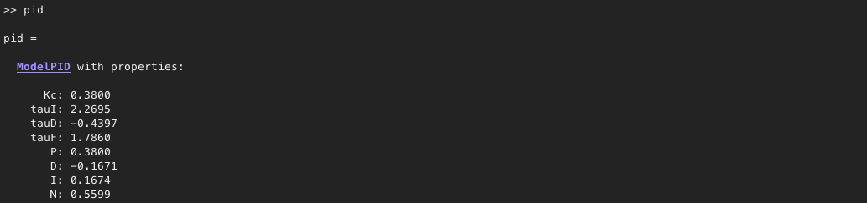

**Figure 10.** Parameters generated by utilising ModelPID.m MATLAB class by using the chosen pole.

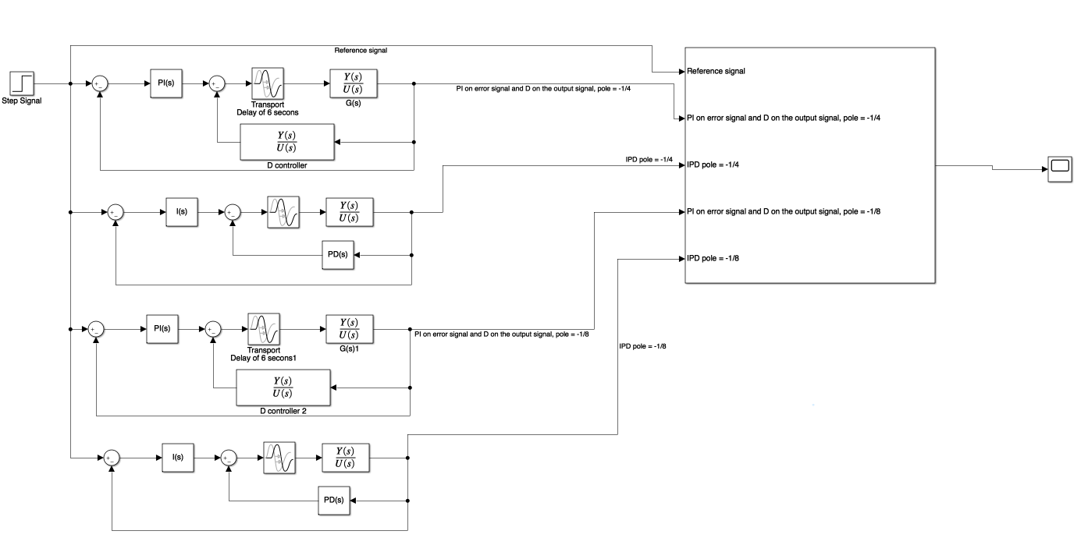

**Figure 11.** Simulink diagram of the simulation.

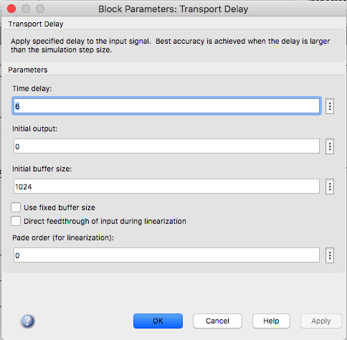

**Figure 12.** Configuration of transport delay for Simulink simulation.



**Figure 13.** Response of poles at -1 vs. -1/2



**Figure 14.** Response of poles at -1/4 Vs. -1/8

From Figure 13, it is shown that pole of -1, the system will oscillate and is unstable as the amplitude of the oscillation increases with time, and the pole at -1/2 create a stable by oscillate response. However, Figure 14 denoted that the pole -1/4 ($λ=1$/4) produces the fastest, the most stable, and a non-oscillate (no overshoot) response, where the PID controller use the orientation of PI controller on the error signal and D controller applied on the output signal. Pole at -1/8 will be ignored since it has slower response than the pole at -1/4. Shown below will be the final Simulink implementation of the chosen pole.

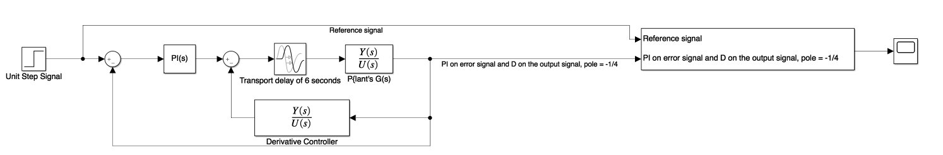

**Figure 15.** Final/chosen Simulink implementation



**Figure 16.** Closed-loop response of the chosen implementation

# Part 3

An underdamped mechanical system is being introduced in this particular task. The system, introduced, has been severely underdamped with an unstable zero. This particular system is expressed by the transfer function of

$$G\left(s\right)= \frac{-s+1}{(s^{2}+0.2s+10)}$$

The closed-loop system of the mechanical system will take input voltage and produce output of the vibration speed. Then, a PID controller is desired to control the mechanical system. However, applying pole cancellation approach that has been done on the previous task won’t be applicable for the current task as the system is oscillatory. Hence, general PID design technique is required to solve the current problem, and it is known that closed-loop poles are all positioned at -10 ($λ=10$). Now, let’s consider the general form of the PID controller transfer function expressed as

$$C\left(s\right)= \frac{c_{2}s^{2}+c_{1}s+ c_{0}}{s(s+ I_{0})}$$

Then, the model based of the plant transfer function (transfer function of the mechanical system) will have the general form of

$$G\left(s\right)=\frac{-s+1}{(s^{2}+0.2s+10)} = \frac{b_{1}s+ b_{0}}{s^{2}+a_{1}s+a_{0}}$$

Therefore, parameters can be found where $b_{1}=-1, b_{0}=1, { a}_{1}=0.2$, and ${ a}_{0}=10$. Proceeding to the next method, the desired closed-loop polynomial is expressed as

$$A_{cl}\left(s\right)=\left(s^{2}+2ξω_{n}s + ω_{n}^{2}\right){\left(s+ λ\right)}^{2}$$

Where $0< ξ<1$ and $ω_{n} ≤ λ$. However, let $A_{cl}\left(s\right)= {{s^{4}+ t}_{3}s}^{3}+ t_{2}s^{2}+t_{1}s+t_{0}$ to simplify the calculation. Therefore, let’s calculate the actual closed-loop transfer function which is represented as

$$T_{cl}\left(s\right)= \frac{G(s)C(s)}{1+G(s)C(s)}$$

Since, only the denominator $T_{cl}\left(s\right)$ is required to be equated with $A_{cl}\left(s\right)$, let’s compute

$$1+G\left(s\right)C\left(s\right)= 0$$

$$1+\left(\frac{b_{1}s+ b_{0}}{s^{2}+a_{1}s+a_{0}}\right)\left(\frac{c_{2}s^{2}+c_{1}s+ c_{0}}{s(s+ I_{0})}\right)= 0$$

$$⟹\frac{s\left(s+ I_{0}\right)(s^{2}+a_{1}s+a_{0})}{s\left(s+ I_{0}\right)(s^{2}+a_{1}s+a_{0})}+\left(\frac{b_{1}s+ b_{0}}{s^{2}+a_{1}s+a_{0}}\right)\left(\frac{c_{2}s^{2}+c_{1}s+ c_{0}}{s(s+ I_{0})}\right)= 0$$

$$⟹s\left(s+ I_{0}\right)(s^{2}+a_{1}s+a_{0})+(b_{1}s+ b_{0})(c_{2}s^{2}+c_{1}s+ c_{0})= 0$$

$$⟹s^{4}+\left(b_{1}c_{2}+ a_{1}+I_{0}\right)s^{3}+\left(b_{1}c_{1}+ b_{0}c_{2}+a_{0}+ a_{1}I_{0}\right)s^{2}+\left(b_{1}c_{0}+ b_{0}c_{1}+ I_{0}a_{0}\right)s+ b_{0}c_{0}= 0$$

$$∴Equate$$

$$s^{4}+\left(b_{1}c_{2}+ a_{1}+I_{0}\right)s^{3}+\left(b_{1}c_{1}+ b_{0}c_{2}+a_{0}+ a_{1}I_{0}\right)s^{2}+\left(b_{1}c_{0}+ b_{0}c_{1}+ I_{0}a_{0}\right)s+ b_{0}c_{0}= {{s^{4}+ t}_{3}s}^{3}+ t_{2}s^{2}+t_{1}s+t_{0}$$

This can be simplified or solved by using matrix operation. Therefore,

$$∴\left[\begin{matrix}1 & b_{1} & 0 & 0 \\ a_{1} & b_{0} & b_{1} & 0 \\ a_{0} & 0 & b_{0} & b_{1} \\ 0 & 0 & 0 & b_{0}\end{matrix}\right]\left[\begin{aligned}\begin{matrix}I_{0} \\ c_{2} \\ c_{1}\end{matrix} \\ c_{0}\end{aligned}\right]= \left[\begin{aligned}\begin{matrix}t_{3}- a_{1} \\ t_{2}- a_{0} \\ t_{1}\end{matrix} \\ t_{0}\end{aligned}\right]$$

$$⟹\left[\begin{aligned}\begin{matrix}I_{0} \\ c_{2} \\ c_{1}\end{matrix} \\ c_{0}\end{aligned}\right]={\left[\begin{matrix}1 & b_{1} & 0 & 0 \\ a_{1} & b_{0} & b_{1} & 0 \\ a_{0} & 0 & b_{0} & b_{1} \\ 0 & 0 & 0 & b_{0}\end{matrix}\right]}^{-1} \left[\begin{aligned}\begin{matrix}t_{3}- a_{1} \\ t_{2}- a_{0} \\ t_{1}\end{matrix} \\ t_{0}\end{aligned}\right]$$

Since, it is known that

$$\left(s^{2}+2ξω_{n}s + ω_{n}^{2}\right){\left(s+ λ\right)}^{2}= {{s^{4}+ t}_{3}s}^{3}+ t_{2}s^{2}+t_{1}s+t_{0}$$

However, since poles are all positioned at -10 ($λ=10$), then $${\left(s+ λ\right)}^{4}= {{s^{4}+ t}_{3}s}^{3}+ t_{2}s^{2}+t_{1}s+t_{0}$$

Therefore, $t_{3}, t_{2}, t_{1}$, and $t_{0}$ can be solved, as shown below.

$$t_{3}=4λ, t_{2}=6λ^{2}, t_{1}=4λ^{3}, \& t_{0}=λ^{4}$$

Since,

$$τ_{f}= \frac{1}{I_{0}}$$

$$τ_{I}= \frac{c_{1}}{c_{2}}- τ_{f}$$

$$K_{c}= τ_{I}τ_{f}c_{0}$$

$$τ_{D}= \frac{c_{2}τ_{I}τ_{f}- K_{c}τ_{I}τ_{f}}{K_{c}τ_{I}}$$

And,

$$P= K_{c}, I= \frac{K_{c}}{τ_{I}}, D= K_{c}τ_{D}, \& N= \frac{1}{τ_{f}}$$

Therefore, the calculation above can be implemented on MATLAB to generate the required parameters for the simulation. Below, is the PID.m MATLAB class utilized for the simulation.

%% Created by: Aditya Prawira

% RMIT ID: S3859061

classdef PID

properties

Kc; tauI; tauD; tauF; P; D; I; N;

end

methods

function obj = PID(I0, c2, c1, c0)

obj.tauF = 1/I0;

obj.tauI = (c1/c0) - obj.tauF;

obj.Kc = obj.tauI*obj.tauF*c0;

obj.tauD = (c2*obj.tauI*obj.tauF - obj.Kc*obj.tauI*obj.tauF)...

/(obj.Kc*obj.tauI);

obj.P = obj.Kc;

obj.I = obj.Kc/obj.tauI;

obj.D = obj.Kc*obj.tauD;

obj.N = 1/(obj.tauF);

end

end

end

**Figure 17.** PID.m MATLAB class

%% Created by: Aditya Prawira

% RMIT ID: S3859061

clear

clc

close all

% Simulation Parameter

time = 10;

disturbance_time = 3;

input_amplitude = 1;

input_disturbance_amplitude = -3;

delta_t = 0.001;

% Plant transfer function numerator parameters

b1 = -1;

b0 = 1;

% Plant transfer function numerator parameters

a1 = 0.2;

a0 = 10;

% Poles of closed-loop

lambda = 10;

t3 = 4*lambda;

t2 = 6*lambda^2;

t1 = 4*lambda^3;

t0 = lambda^4;

% Plant transfer function

Gs = tf([b1 b0], [1 a1 a0]);

Sy = [1 b1 0 0; a1 b0 b1 0; a0 0 b0 b1; 0 0 0 b0];

Acl = [t3 - a1; t2 - a0; t1; t0];

params = (num2cell(Sy\Acl));

[I0, c2, c1, c0] = params{:};

pid = PID(I0, c2, c1, c0);

D = tf([pid.Kc*pid.tauD 0], [pid.tauF 1]);

**Figure 18.** Params3.m MATLAB program

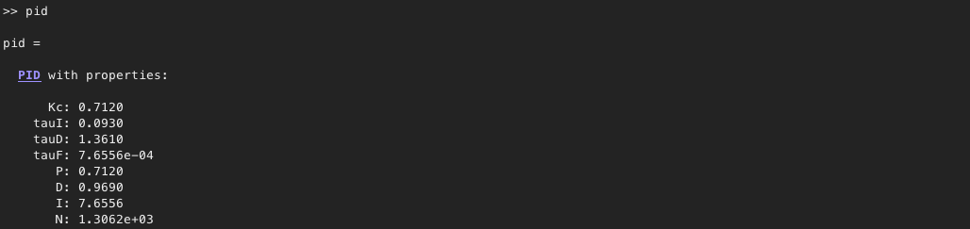

**Figure 19.** Parameters generated by utilising PID.m MATLAB class.

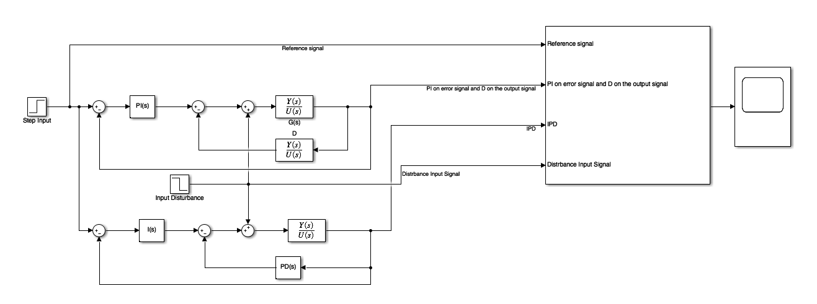

**Figure 20.** Simulink diagram of task 3



**Figure 21.** Simulation of task 3

From the figure above, it is shown that the by implementing PI on error signal and D controller on the output signal, gives a very fast response. However, it has greater amplitude on the negatives compare to the IPD system. The IPD on the other hand, provide slower response, but it has shorter amplitude on the negatives. Furthermore, the responses between 2 PID implementations seem be at sync for the rest of the simulation time. It can be seen that the effect of input disturbance at t = 3, it creates an overshoot but then it produces almost same response that has been produced initially by the IPD system.

# Part 4

Robot arm has been introduced for this task, where the system is being represented as a transfer function of

$$G\left(s\right)= \frac{10}{(0.1s+s)s}$$

A resonant controller is desired so that it allows the robot arm to keep track of the sinusoidal reference signal of $r\left(t\right)= R_{m}sin\left(ω_{0}t+ θ_{0}\right)= 3sin\left(ω_{0}t\right)$, as $ω_{0}= \sqrt{2}$. It is also known that poles of the closed-loop system are all positioned at -8 ($λ=8$). For this particular case, pole-assignment approach will be utilized to find the parameter of the resonant controller which has general form of

$$C\left(s\right)=\frac{c_{2}s^{2}+c_{1}s+ c_{0}}{s^{2}+ω_{0}^{2}} = \frac{P(s)}{L(s)}$$

Now, let’s change the form of the plant’s (robot arm) transfer function to be in form of

$$G\left(s\right)= \frac{10}{(0.1s+s)s}= \frac{100}{(s+10)s}$$

The pole of the transfer function is then located at $s_{1}= -10, s_{2}=0$. Since the pole at zero has the most dominance, then let s = 0 for the weakest pole.

$$∴G\left(s\right)= \frac{100}{(0+10)s}= \frac{10}{s}$$

From here, it is known that the general form of the transfer function is to be represented as

$$G\left(s\right) =\frac{b}{s+a}= \frac{B(s)}{A(s)}$$

Therefore, $a=0$, and $b=10$. The desired polynomial of the closed-loop system is presented as

$$A_{cl}\left(s\right)=\left(s^{2}+2ξω_{n}s + ω_{n}^{2}\right)\left(s+ λ\right)$$

Where $0< ξ<1$ and $ω_{n} ≤ λ$, and by let $A_{cl}\left(s\right)= s^{3}+ t_{2}s^{2}+t_{1}s+t_{0}$. Now, let’s equate the denominator of the actual closed-loop transfer function with the desired polynomial. This process can be computed by

$$L\left(s\right)A\left(s\right)+P\left(s\right)B\left(s\right)= A_{cl}\left(s\right)$$

Which is the simplified method of finding the denominator of the actual closed-loop transfer function $T_{cl}\left(s\right)$ and equate it with $A_{cl}\left(s\right)$.

$$⟹(s^{2}+ω_{0}^{2})(s+a)+(c_{2}s^{2}+c_{1}s+ c_{0})b= A_{cl}\left(s\right)$$

Since, $a=0$, and $b=10$

$$∴(s^{2}+ω_{0}^{2})(s)+(c_{2}s^{2}+c_{1}s+ c_{0})10= s^{3}+ t_{2}s^{2}+t_{1}s+t_{0}$$

$$⟹s^{3}+10c_{2}s^{2}+\left(ω_{0}^{2}+10c_{1}\right)s+10c_{0}= s^{3}+ t_{2}s^{2}+t_{1}s+t_{0}$$

Hence,

$$c_{2}= \frac{t_{2}}{10}, c_{1}= \frac{t_{1}- ω_{0}^{2}}{10}, c_{0}= \frac{t_{0}}{10}$$

Since poles of the closed-loop system are all positioned at -8 ($λ=8$), then

$${(s+ λ)}^{3}= s^{3}+ t_{2}s^{2}+t_{1}s+t_{0}$$

Hence,

$$t_{2}=3λ$$

$$t_{1}=3λ^{2}$$

$$t_{0}= λ^{3}$$

Therefore, the derivation above now can be implemented in MATLAB to generate parameters required for the simulation.

%% Created by: Aditya Prawira

% RMIT ID: S3859061

clc

clear

close all

Gs = tf(100, [1 10 0]); % Robot arm transfer function

Rm = 3; % Amplitude of reference signal

w0 = sqrt(2); % Reference signal frequency

lambda = 8; % closed-loop pole

a = 0; b = 10;

%% Parameters that can be changed %%

sampling_time = 0.001;

simulation_time = 50;

%% Calculate parameters for resonant controller (Applying pole-assignment)

t2 = 3*lambda;

t1 = 3*lambda^2;

t0 = lambda^3;

c2 = (t2 - a)/b;

c1 = (t1 - w0^2)/b;

c0 = (t0 - (a * w0^2))/b;

ResonantController = tf([c2 c1 c0], [1 0 w0^2]); % Resonant controller

**Figure 22.** resonant_params.m MATLAB program

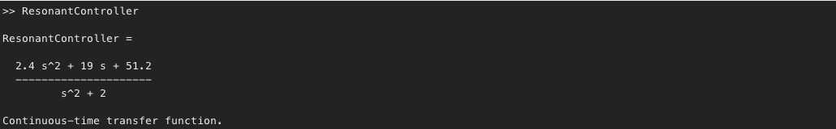

**Figure 23.** Resonant controller transfer function generated from MATLAB program above on Figure 22.

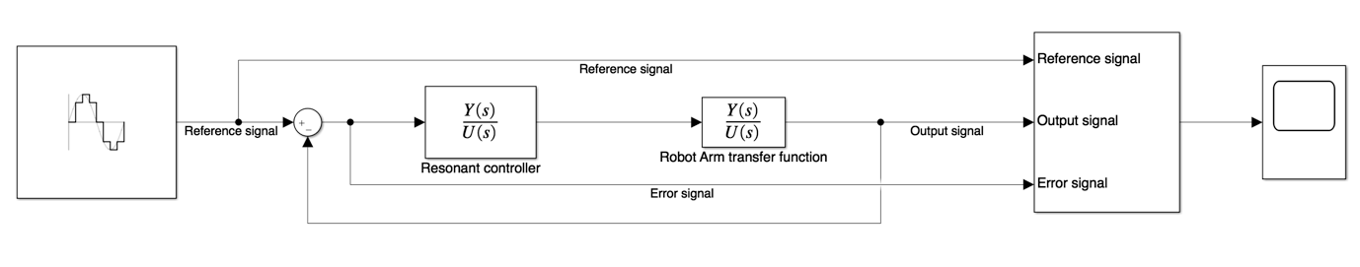

**Figure 24.** Simulink diagram for task 4.



**Figure 25.** Simulation of task 4

As what has been shown from the response, the error signal is eventually reaches 0 as $t→∞$. Now, to prove this, let’s utilize final value theorem, to show that

$$\lim_{t→∞}{e\left(t\right)=\lim_{s→0}{sE\left(s\right)=0}}$$

Now a closed-loop system represented by the Simulink diagram (Figure 24), it is known that

$$\frac{Y(s)}{R(s)}=\frac{G(s)C(s)}{1+G(s)C(s)}$$

$$⟹Y(s)=R(s)\left(\frac{G(s)C(s)}{1+G(s)C(s)}\right)$$

Now the Laplace transform of the reference signal is

$$R\left(s\right)= L\left\{r(t)\right\}= L\left\{3sin\left(ω_{0}t\right)\right\}=\frac{3ω_{0}}{s^{2}+ ω_{0}^{2}}$$

And

$$\frac{G(s)C(s)}{1+G(s)C(s)}=\frac{b(c_{2}s^{2}+c_{1}s+ c_{0})}{(s^{2}+ω_{0}^{2})(s+a)+(c_{2}s^{2}+c_{1}s+ c_{0})b}$$

$$∴Y\left(s\right)=R(s)\left(\frac{b(c_{2}s^{2}+c_{1}s+ c_{0})}{(s^{2}+ω_{0}^{2})(s+a)+(c_{2}s^{2}+c_{1}s+ c_{0})b}\right)$$

Then,

$$L\left\{e(t)\right\}= L\left\{r\left(t\right)-y(t)\right\}$$

$$⇒E\left(s\right)=R\left(s\right)-Y\left(s\right)$$

$$⇒E\left(s\right)=R\left(s\right)-R(s)\left(\frac{b(c_{2}s^{2}+c_{1}s+ c_{0})}{(s^{2}+ω_{0}^{2})(s+a)+(c_{2}s^{2}+c_{1}s+ c_{0})b}\right)$$

$$⇒E\left(s\right)=\frac{3ω_{0}}{s^{2}+ ω_{0}^{2}}\left(1- \frac{b(c_{2}s^{2}+c_{1}s+ c_{0})}{(s^{2}+ω_{0}^{2})(s+a)+(c_{2}s^{2}+c_{1}s+ c_{0})b}\right)$$

$$⇒E\left(s\right)=\frac{3ω_{0}}{s^{2}+ ω_{0}^{2}}\left( \frac{\left(s^{2}+ω_{0}^{2}\right)\left(s+a\right)+b\left(c_{2}s^{2}+c_{1}s+ c_{0}\right)- b(c_{2}s^{2}+c_{1}s+ c_{0})}{(s^{2}+ω_{0}^{2})(s+a)+(c_{2}s^{2}+c_{1}s+ c_{0})b}\right)$$

$$⇒E\left(s\right)=\frac{3ω_{0}}{s^{2}+ ω_{0}^{2}}\left( \frac{\left(s^{2}+ω_{0}^{2}\right)\left(s+a\right)}{(s^{2}+ω_{0}^{2})(s+a)+(c_{2}s^{2}+c_{1}s+ c_{0})b}\right)$$

$$⇒E\left(s\right)=\frac{3ω_{0}\left(s+a\right)}{(s^{2}+ω_{0}^{2})(s+a)+(c_{2}s^{2}+c_{1}s+ c_{0})b}$$

Since $a=0$, and $b=10$

$$∴E\left(s\right)=\frac{3ω_{0}s}{s(s^{2}+ω_{0}^{2})+10(c_{2}s^{2}+c_{1}s+ c_{0})}$$

Now,

$$\lim_{t→∞}{e\left(t\right)=\lim_{s→0}{sE\left(s\right)= \lim_{s→0}{s\left(\frac{3ω_{0}s}{s(s^{2}+ω_{0}^{2})+10(c_{2}s^{2}+c_{1}s+ c_{0})}\right)=0\left(\frac{0}{0+10c_{0}}\right)}}}=0$$

The response above has been proven by the final value theorem that

$$\lim_{t→∞}{e\left(t\right)=\lim_{s→0}{sE\left(s\right)=0}}$$

With this method it shows that the simulation produces a convincing response.